ClONAL vs. MASSAL SELECTION
www.danielamasterswine.com

CLONING
- Definition:
  - True meaning: an identical copy
  - Within the winemaking world, cloning grapes is the selection and propagation of a particular vine that has characteristics that set it apart from the majority
    - Mother plant is chosen for its varietal identity, its phenotypic traits and its sanitary state
    - Propagated using cuttings from single plant
  - Clones are different from the general population but are identical to each other within the clonal group.
- Advantages
  - Is a handy way to overcome vine diseases by only propagating “clean” cuttings
  - Ensures that all vines are identical and respond similarly to various stimuli
  - Easy to purchase from nursery in bulk quantities (refer to notes on Establishment of New Vineyards)
- Disadvantages:
  - If all vines in the same area are closely related, the spread of disease is easy.
  - Some clones are very specialized and only suitable for certain regions and styles of wine.
  - Clonal selection has led to an increase in yield leading to overproduction
  - Led to a reduction in vine genetic resources. To counter, collectors of old varieties have been collected both in the field and in vitro (Massal Selection)
  - Argument: Is the wine as complex with clones vs. with biologically diverse vines?
  - How to get past these disadvantages: inter-clonal planting https://daily.sevenfifty.com/overturning-the-monoclonal-status-quo/
- History
  - Method popularized in the 1960’s and 1970’s to overcome vine diseases
  - Scientists at UC Davis figured out how to heat treat imported vine cuttings to “clean” them. The vines were then registered as clones and propagated at nurseries and sold all over the US as the wines we know today (Pinot Noir Clone 777, Cabernet Sauvignon Clone 6, etc). UC Davis still runs one of the top clonal selection programs in the world.
  - Clones used to jump start the wine industry after Prohibition.
    - UC Davis and professor Harold Olmo provided clean, virus-free, high yielding stock (Chardonnay FPMS clone 04).
    - Prior, vines were poor yielding of poor quality because of the contamination of viruses
- Rules and Regulations around the World
  - Germany: There is a formal process of clonal evaluation and a systematic numbering system. (Geisenheim Research Institute)
  - France: After each clone has passed through a period of sanity and genetic selection it undergoes registration and is assigned a unique certification number by ONIVINS (Office National Interprofessionnel des Vins France) after approval by the CTPS (Committee of Selection of Cultivated Plants of the French Ministry of Agriculture).
  - Italy: Vivai Cooperativi Rauscedo
  - Between France & US-A large number of clones developed by ENTAV (Etablissement National Technique pour l’Amélioration de la Viticulture) & INRA are available throughout the US.
    - French authorities have attempted to control the movement of their materials by the establishment of propagation licenses with a limited number of California nurseries
      - French authorities value efforts invested in their development.
      - There is competition from the same genetic material imported from non-French government approved sources.
      - Some non-approved clones are certified by CDFA (California Department of Food & Agriculture).
  - International Organization of Vine and Wine: Process for the Clonal Selection of Vines: chrome-extension://oemmndcbldboiebfnladdacbdfmadadm/http://www.oiv.int/public/medias/5382/oiv-viti-564a-2017-en.pdf
    - And in case you want to know who belongs to the OIV: http://www.oiv.int/en/the-international-organisation-of-vine-and-wine/member-states-and-observers
- Types of Clones
  - Oregon: Many Oregon growers select specific clones of Pinot noir (e.g., Pommard, Dijon 115, and Dijon 777) for their ripening timing and/or fruit quality characteristics.
  - Argentina: Mendoza Clone to withstand high altitude
  - Heritage Clones: those collected from premier vineyards with a reputation for quality wine

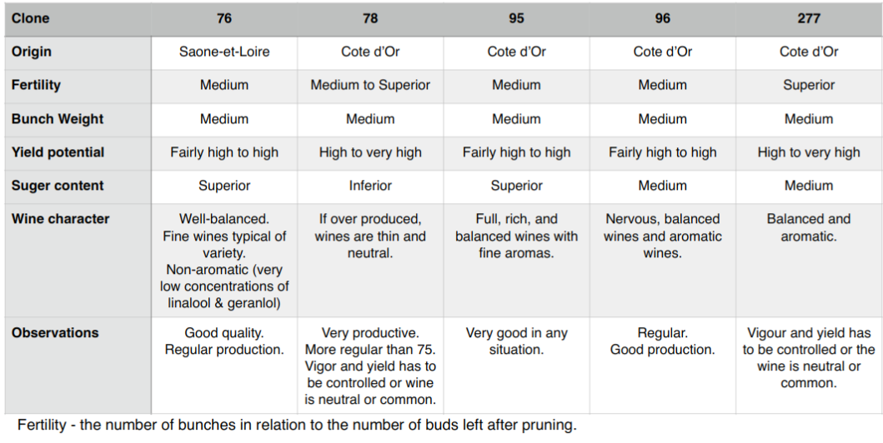

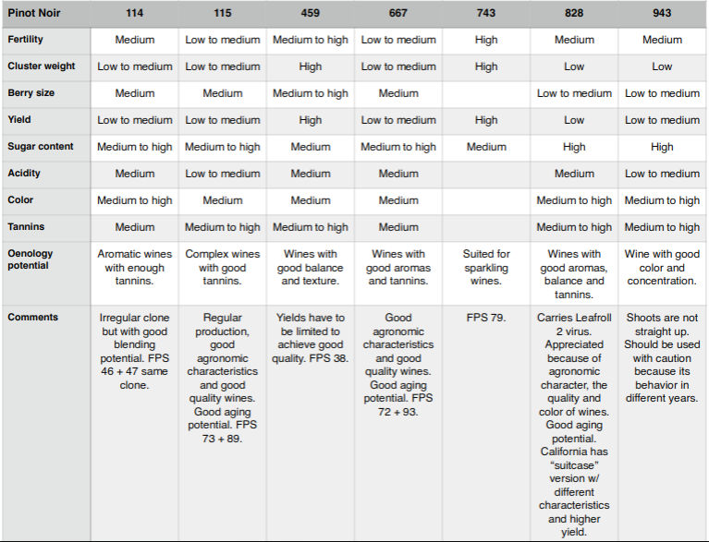

MASSAL SELECTION

- Definition:
  - Selection Massale (aka Massal Selection) is a French wine growing term for the practice of replanting new vineyards with cuttings from exceptional old vines from the same (or nearby) property.
  - Called the “old way” of propagating vineyards that’s been replaced with vine clone nurseries.
- Advantages
  - Prevents whole vineyards from being wiped out when a new disease comes sweeps through
  - Older cuttings are more resistant to disease than younger ones
  - Perhaps creates a more complex wine? (Debatable)
- Disadvantages
  - Time-consuming (identify and take cuttings from several of the “best” vines, root them, graft them, plant them, etc)
  - Some cuttings may be diseased/virused already and one wouldn’t know unless they’ve been screened by a nursery
  - In America, discouraged by nurseries, thus more clandestine
- Proponents of Massal Selection
  - Ch. Lynch Bages: https://www.thewinecellarinsider.com/wine-topics/jean-michel-cazes-massal-clonal-selection-lynch-bages/
  - Mount Eden Vineyards (Santa Cruz)

